heart_disease | Method | N | Mean | Std Dev | Std Err | Minimum | Maximum
0 |  | 246 | 48.7683 | 8.5030 | 0.5421 | 34.0000 | 67.0000
1 |  | 56 | 54.7500 | 8.4493 | 1.1291 | 38.0000 | 68.0000
Diff (1-2) | Pooled |  | -5.9817 | 8.4932 | 1.2575
Diff (1-2) | Satterthwaite |  | -5.9817 |  | 1.2525

heart_disease | Method | Mean | 95% CL Mean |  | Std Dev | 95% CL Std Dev
0 |  | 48.7683 | 47.7005 | 49.8361 | 8.5030 | 7.8122 | 9.3289
1 |  | 54.7500 | 52.4873 | 57.0127 | 8.4493 | 7.1234 | 10.3864
Diff (1-2) | Pooled | -5.9817 | -8.4564 | -3.5070 | 8.4932 | 7.8646 | 9.2319
Diff (1-2) | Satterthwaite | -5.9817 | -8.4732 | -3.4902

Method | Variances | DF | t Value | Pr > |t|
Pooled | Equal | 300 | -4.76 | <.0001
Satterthwaite | Unequal | 82.301 | -4.78 | <.0001

Equality of Variances
Method | Num  DF | Den  DF | F Value | Pr > F
Folded F | 245 | 55 | 1.01 | 0.9879

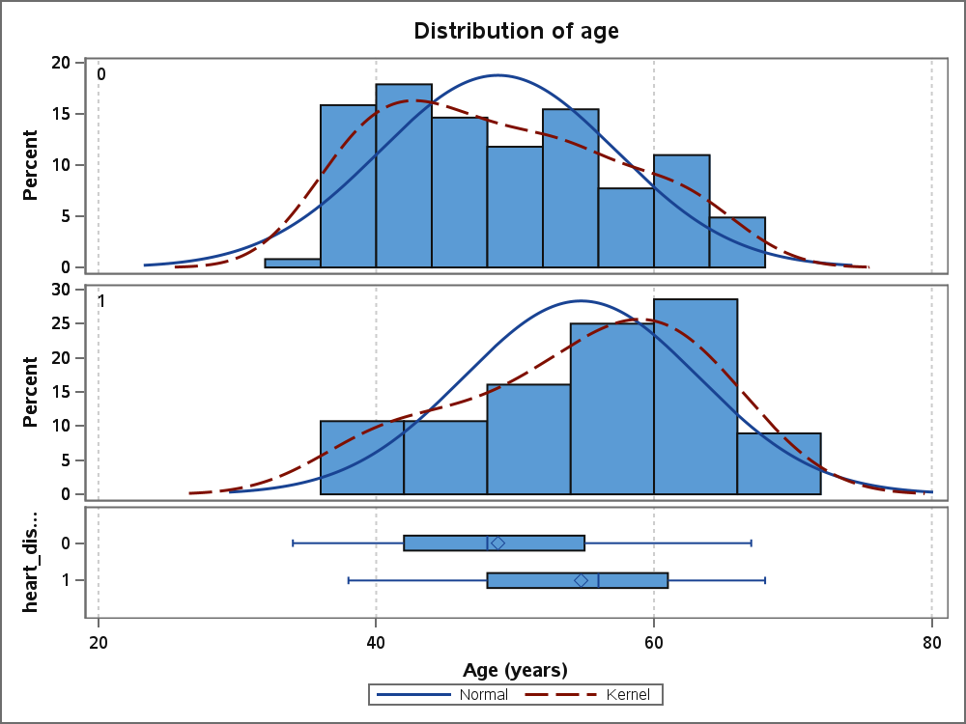
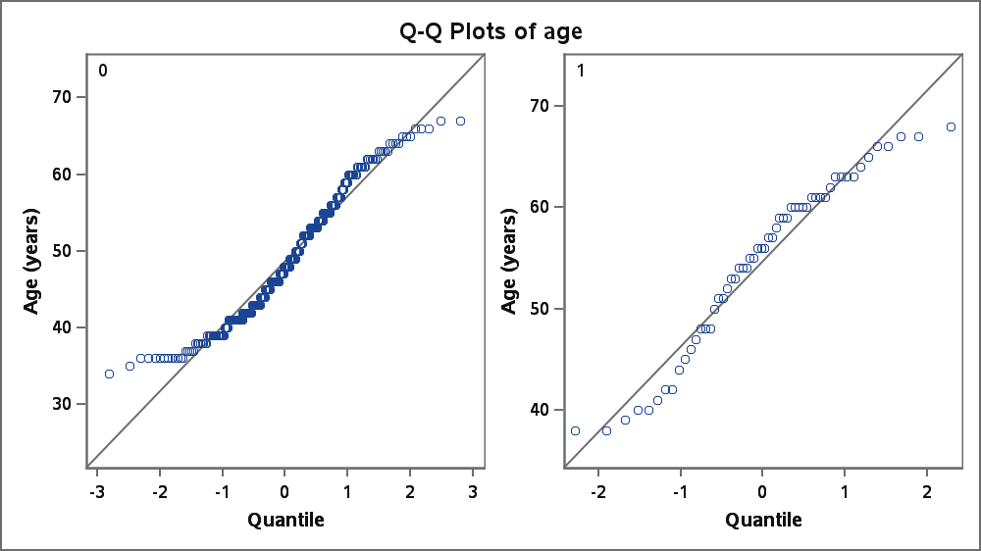
Variable: cigsPerDay

heart_disease | Method | N | Mean | Std Dev | Std Err | Minimum | Maximum
0 |  | 246 | 9.3496 | 12.3757 | 0.7890 | 0 | 60.0000
1 |  | 56 | 9.0000 | 13.0579 | 1.7449 | 0 | 43.0000
Diff (1-2) | Pooled |  | 0.3496 | 12.5036 | 1.8513
Diff (1-2) | Satterthwaite |  | 0.3496 |  | 1.9150

heart_disease | Method | Mean | 95% CL Mean |  | Std Dev | 95% CL Std Dev
0 |  | 9.3496 | 7.7954 | 10.9038 | 12.3757 | 11.3702 | 13.5778
1 |  | 9.0000 | 5.5031 | 12.4969 | 13.0579 | 11.0088 | 16.0515
Diff (1-2) | Pooled | 0.3496 | -3.2936 | 3.9928 | 12.5036 | 11.5782 | 13.5911
Diff (1-2) | Satterthwaite | 0.3496 | -3.4622 | 4.1614

Method | Variances | DF | t Value | Pr > |t|
Pooled | Equal | 300 | 0.19 | 0.8503
Satterthwaite | Unequal | 79.05 | 0.18 | 0.8556

Equality of Variances
Method | Num  DF | Den  DF | F Value | Pr > F
Folded F | 55 | 245 | 1.11 | 0.5770

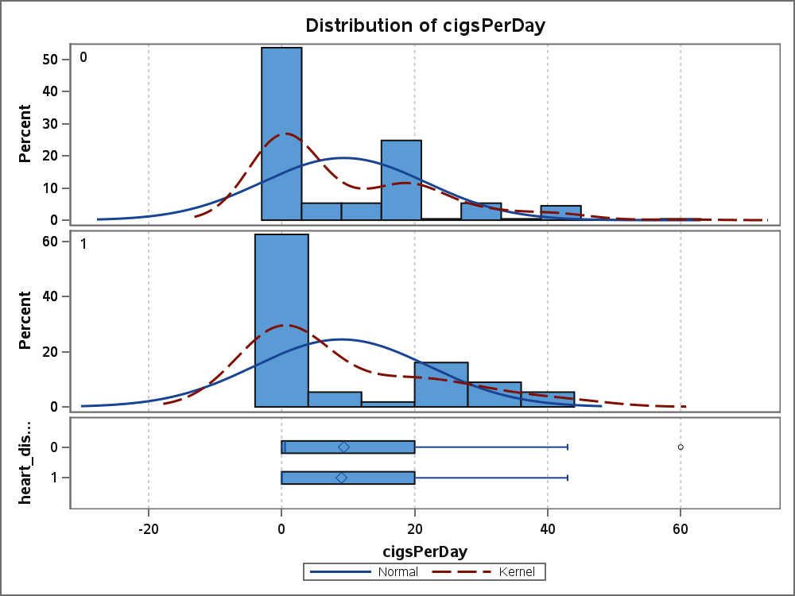
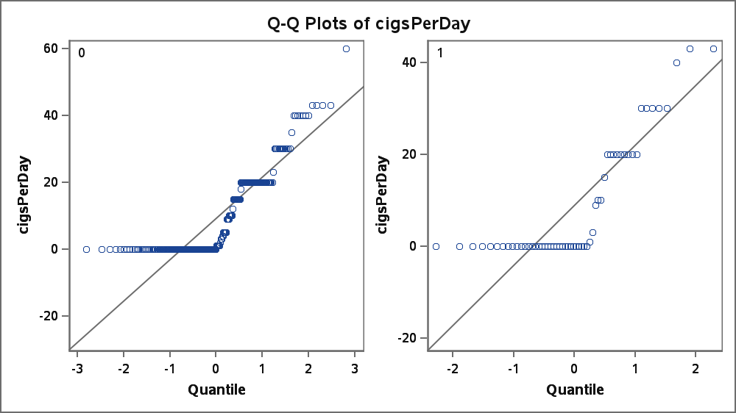
Variable: totChol

heart_disease | Method | N | Mean | Std Dev | Std Err | Minimum | Maximum
0 |  | 246 | 235.7 | 42.5114 | 2.7104 | 135.0 | 368.0
1 |  | 56 | 256.4 | 49.6888 | 6.6399 | 164.0 | 464.0
Diff (1-2) | Pooled |  | -20.7400 | 43.9151 | 6.5021
Diff (1-2) | Satterthwaite |  | -20.7400 |  | 7.1718

heart_disease | Method | Mean | 95% CL Mean |  | Std Dev | 95% CL Std Dev
0 |  | 235.7 | 230.3 | 241.0 | 42.5114 | 39.0574 | 46.6407
1 |  | 256.4 | 243.1 | 269.7 | 49.6888 | 41.8913 | 61.0802
Diff (1-2) | Pooled | -20.7400 | -33.5356 | -7.9444 | 43.9151 | 40.6648 | 47.7346
Diff (1-2) | Satterthwaite | -20.7400 | -35.0289 | -6.4510

Method | Variances | DF | t Value | Pr > |t|
Pooled | Equal | 300 | -3.19 | 0.0016
Satterthwaite | Unequal | 74.392 | -2.89 | 0.0050

Equality of Variances
Method | Num  DF | Den  DF | F Value | Pr > F
Folded F | 55 | 245 | 1.37 | 0.1168

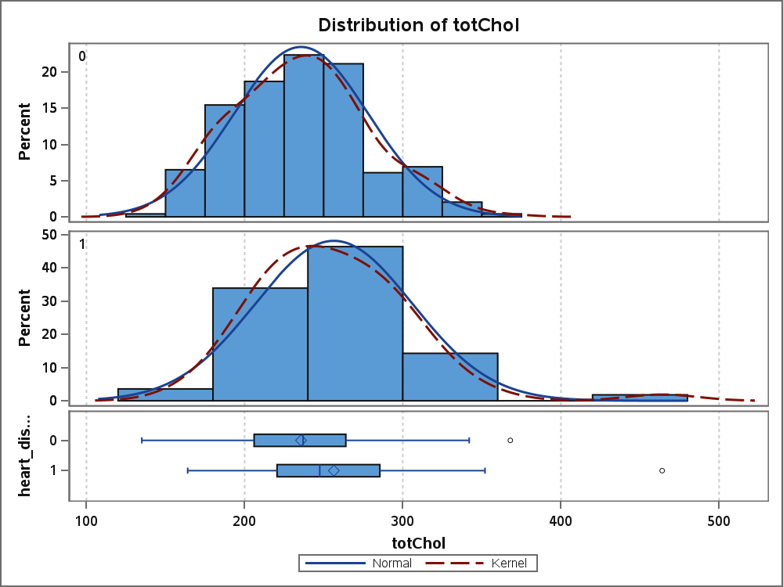
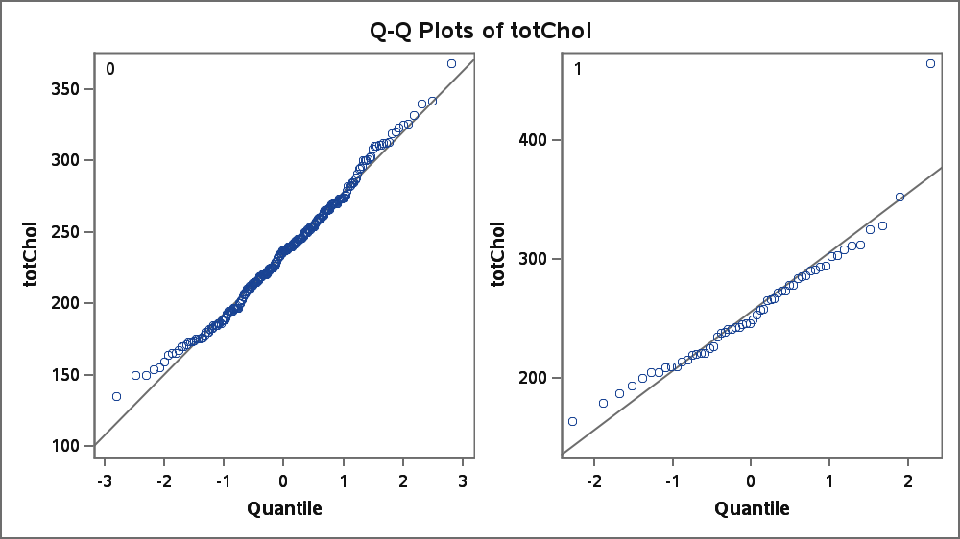
Variable: sysBP (Systolic Blood Pressure)

heart_disease | Method | N | Mean | Std Dev | Std Err | Minimum | Maximum
0 |  | 246 | 130.5 | 21.6796 | 1.3822 | 94.0000 | 204.0
1 |  | 56 | 143.5 | 24.5125 | 3.2756 | 102.0 | 212.0
Diff (1-2) | Pooled |  | -12.9887 | 22.2260 | 3.2908
Diff (1-2) | Satterthwaite |  | -12.9887 |  | 3.5553

heart_disease | Method | Mean | 95% CL Mean |  | Std Dev | 95% CL Std Dev
0 |  | 130.5 | 127.8 | 133.2 | 21.6796 | 19.9182 | 23.7854
1 |  | 143.5 | 136.9 | 150.0 | 24.5125 | 20.6658 | 30.1321
Diff (1-2) | Pooled | -12.9887 | -19.4647 | -6.5127 | 22.2260 | 20.5810 | 24.1590
Diff (1-2) | Satterthwaite | -12.9887 | -20.0700 | -5.9073

Method | Variances | DF | t Value | Pr > |t|
Pooled | Equal | 300 | -3.95 | <.0001
Satterthwaite | Unequal | 75.792 | -3.65 | 0.0005

Equality of Variances
Method | Num  DF | Den  DF | F Value | Pr > F
Folded F | 55 | 245 | 1.28 | 0.2164

T-Test Interpretation: Systolic Blood Pressure (sysBP)
- An independent two-sample t-test was performed to compare systolic blood pressure between participants with and without heart disease.
- There were 246 participants without heart disease and 56 participants with heart disease.
- The mean systolic blood pressure was 130.5 mmHg in the non-heart-disease group and 143.5 mmHg in the heart-disease group.
- The heart-disease group therefore had an approximately 13.0 mmHg higher mean systolic blood pressure.
- The Folded F test for equality of variances gave p = 0.2164, which is greater than 0.05. Thus, there was no significant difference in variances, supporting the equal-variance assumption.
- The pooled t-test showed t = −3.95, with df = 300 and p < 0.0001.
- Since p < 0.05, the null hypothesis of equal mean systolic blood pressure between the two groups was rejected.
- The 95% confidence interval for the mean difference was −19.46 to −6.51 mmHg, which does not include zero, further supporting a statistically significant difference.
- The Satterthwaite t-test also gave a significant result (p = 0.0005), confirming the robustness of the finding.
- Conclusion: Systolic blood pressure was significantly higher among participants with heart disease compared with those without heart disease in this dataset.

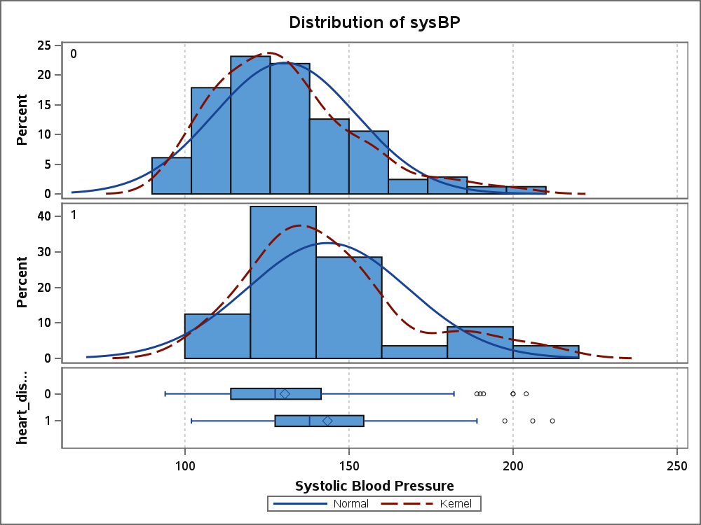
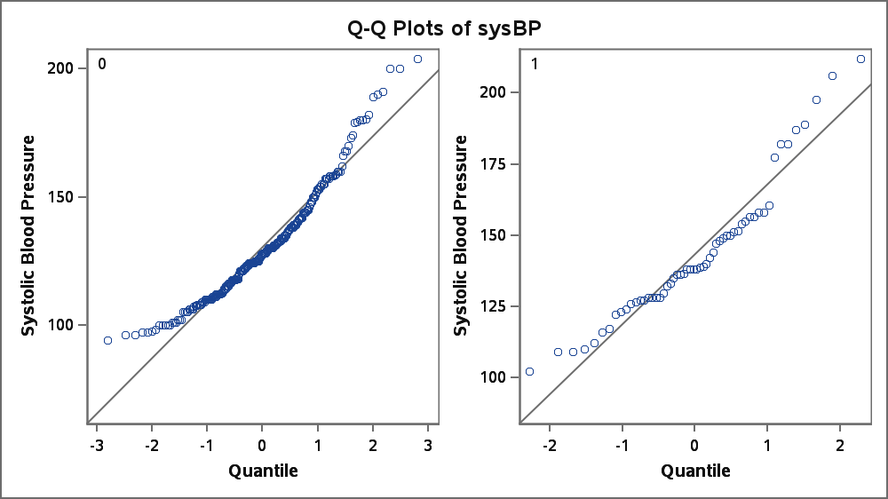

Variable: diaBP (Diastolic Blood Pressure)

heart_disease | Method | N | Mean | Std Dev | Std Err | Minimum | Maximum
0 |  | 246 | 81.3537 | 11.4277 | 0.7286 | 57.0000 | 124.5
1 |  | 56 | 87.1964 | 12.4114 | 1.6585 | 66.0000 | 121.0
Diff (1-2) | Pooled |  | -5.8428 | 11.6143 | 1.7196
Diff (1-2) | Satterthwaite |  | -5.8428 |  | 1.8115

heart_disease | Method | Mean | 95% CL Mean |  | Std Dev | 95% CL Std Dev
0 |  | 81.3537 | 79.9185 | 82.7888 | 11.4277 | 10.4992 | 12.5377
1 |  | 87.1964 | 83.8726 | 90.5202 | 12.4114 | 10.4637 | 15.2568
Diff (1-2) | Pooled | -5.8428 | -9.2268 | -2.4587 | 11.6143 | 10.7547 | 12.6244
Diff (1-2) | Satterthwaite | -5.8428 | -9.4495 | -2.2360

Method | Variances | DF | t Value | Pr > |t|
Pooled | Equal | 300 | -3.40 | 0.0008
Satterthwaite | Unequal | 77.628 | -3.23 | 0.0018

Equality of Variances
Method | Num  DF | Den  DF | F Value | Pr > F
Folded F | 55 | 245 | 1.18 | 0.4014

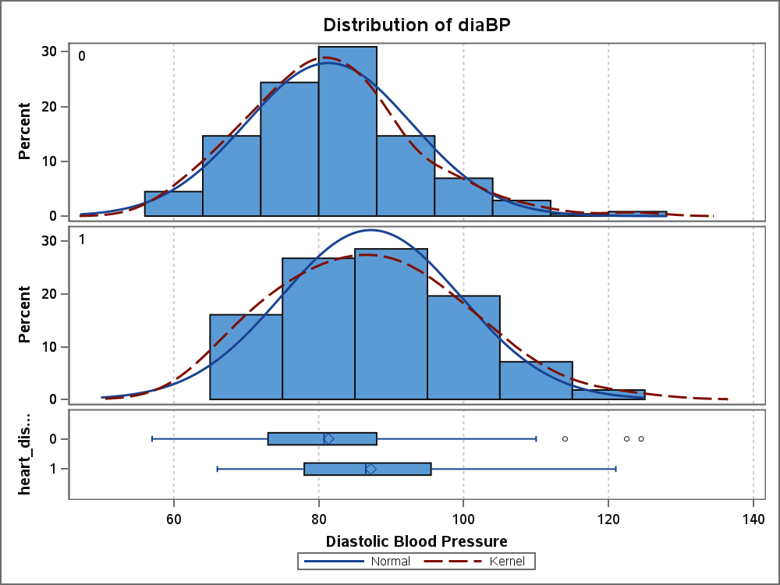
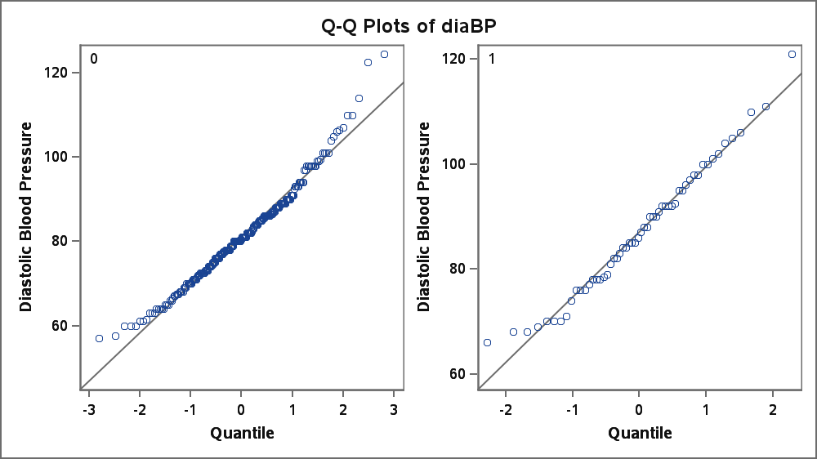
Variable: BMI

heart_disease | Method | N | Mean | Std Dev | Std Err | Minimum | Maximum
0 |  | 246 | 25.6731 | 4.3651 | 0.2783 | 16.7500 | 45.8000
1 |  | 56 | 27.0009 | 4.7349 | 0.6327 | 19.8800 | 40.5200
Diff (1-2) | Pooled |  | -1.3278 | 4.4352 | 0.6567
Diff (1-2) | Satterthwaite |  | -1.3278 |  | 0.6912

heart_disease | Method | Mean | 95% CL Mean |  | Std Dev | 95% CL Std Dev
0 |  | 25.6731 | 25.1249 | 26.2213 | 4.3651 | 4.0104 | 4.7891
1 |  | 27.0009 | 25.7329 | 28.2689 | 4.7349 | 3.9918 | 5.8204
Diff (1-2) | Pooled | -1.3278 | -2.6201 | -0.0355 | 4.4352 | 4.1069 | 4.8209
Diff (1-2) | Satterthwaite | -1.3278 | -2.7040 | 0.0484

Method | Variances | DF | t Value | Pr > |t|
Pooled | Equal | 300 | -2.02 | 0.0441
Satterthwaite | Unequal | 77.688 | -1.92 | 0.0584

Equality of Variances
Method | Num  DF | Den  DF | F Value | Pr > F
Folded F | 55 | 245 | 1.18 | 0.4084

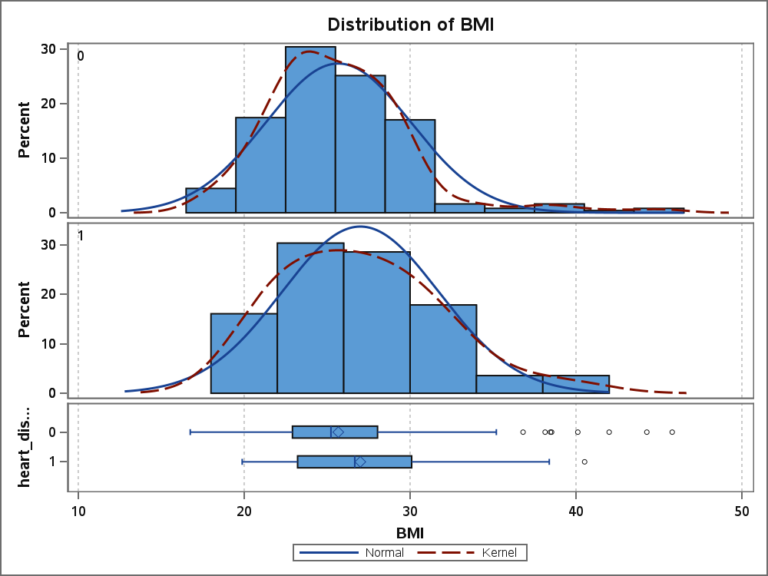
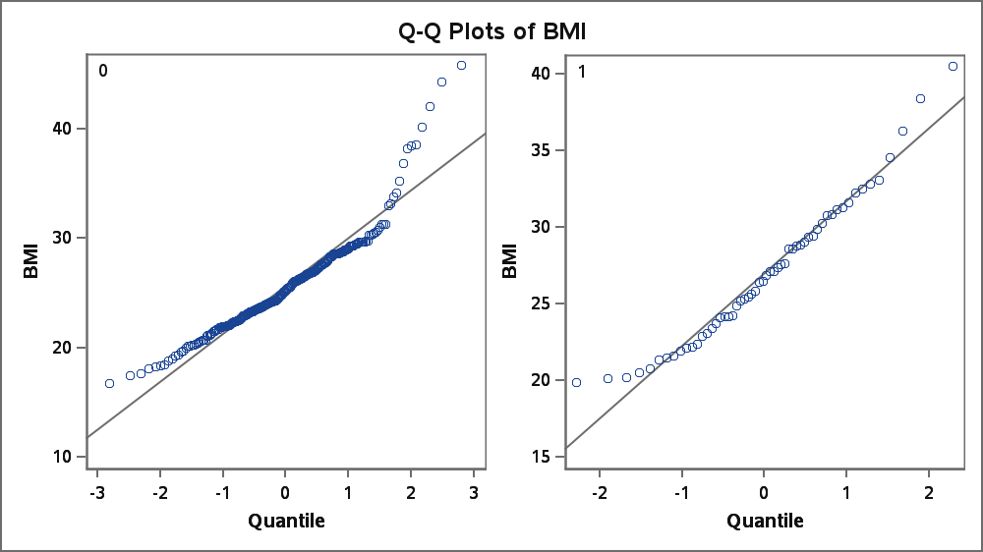
Variable: heartRate (Heart Rate)

heart_disease | Method | N | Mean | Std Dev | Std Err | Minimum | Maximum
0 |  | 246 | 75.5813 | 12.0945 | 0.7711 | 50.0000 | 140.0
1 |  | 56 | 74.8036 | 11.8604 | 1.5849 | 55.0000 | 110.0
Diff (1-2) | Pooled |  | 0.7777 | 12.0519 | 1.7844
Diff (1-2) | Satterthwaite |  | 0.7777 |  | 1.7626

heart_disease | Method | Mean | 95% CL Mean |  | Std Dev | 95% CL Std Dev
0 |  | 75.5813 | 74.0624 | 77.1002 | 12.0945 | 11.1119 | 13.2693
1 |  | 74.8036 | 71.6273 | 77.9798 | 11.8604 | 9.9992 | 14.5795
Diff (1-2) | Pooled | 0.7777 | -2.7338 | 4.2893 | 12.0519 | 11.1599 | 13.1001
Diff (1-2) | Satterthwaite | 0.7777 | -2.7279 | 4.2833

Method | Variances | DF | t Value | Pr > |t|
Pooled | Equal | 300 | 0.44 | 0.6633
Satterthwaite | Unequal | 83.076 | 0.44 | 0.6602

Equality of Variances
Method | Num  DF | Den  DF | F Value | Pr > F
Folded F | 245 | 55 | 1.04 | 0.8891

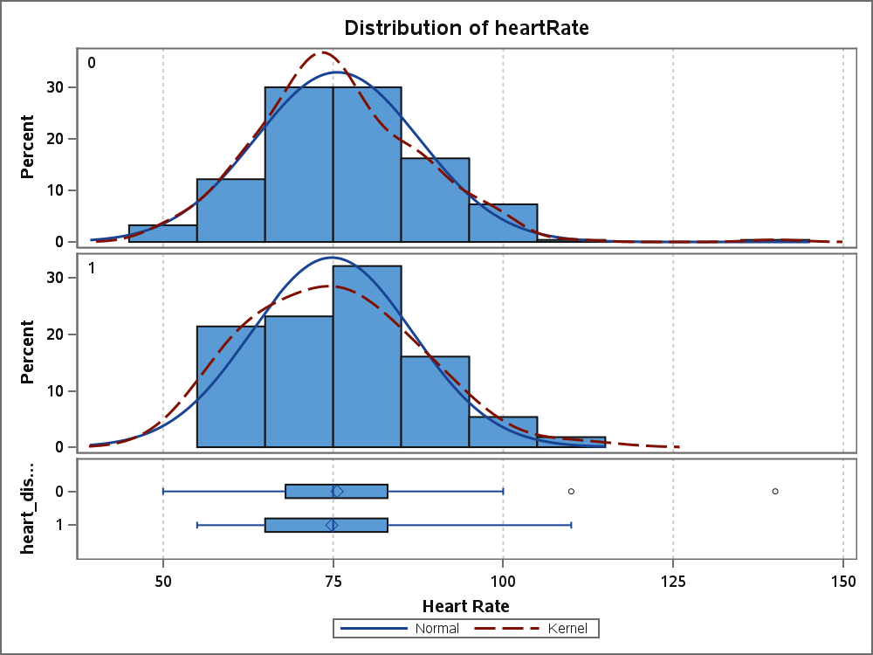
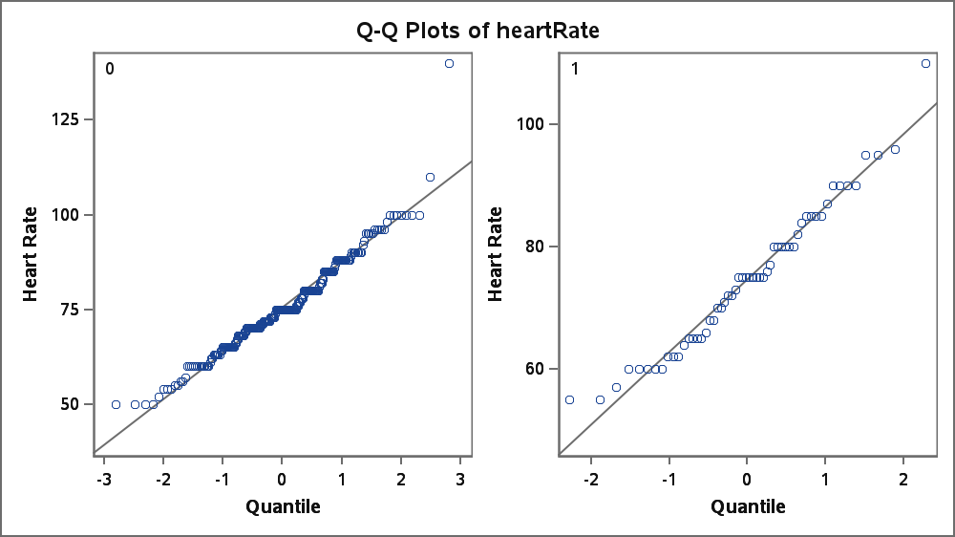
Variable: glucose

heart_disease | Method | N | Mean | Std Dev | Std Err | Minimum | Maximum
0 |  | 246 | 80.1463 | 18.2283 | 1.1622 | 45.0000 | 225.0
1 |  | 56 | 84.7857 | 22.6368 | 3.0250 | 54.0000 | 215.0
Diff (1-2) | Pooled |  | -4.6394 | 19.1128 | 2.8299
Diff (1-2) | Satterthwaite |  | -4.6394 |  | 3.2406

heart_disease | Method | Mean | 95% CL Mean |  | Std Dev | 95% CL Std Dev
0 |  | 80.1463 | 77.8572 | 82.4355 | 18.2283 | 16.7473 | 19.9989
1 |  | 84.7857 | 78.7235 | 90.8479 | 22.6368 | 19.0845 | 27.8264
Diff (1-2) | Pooled | -4.6394 | -10.2083 | 0.9295 | 19.1128 | 17.6982 | 20.7751
Diff (1-2) | Satterthwaite | -4.6394 | -11.0992 | 1.8204

Method | Variances | DF | t Value | Pr > |t|
Pooled | Equal | 300 | -1.64 | 0.1022
Satterthwaite | Unequal | 72.083 | -1.43 | 0.1566

Equality of Variances
Method | Num  DF | Den  DF | F Value | Pr > F
Folded F | 55 | 245 | 1.54 | 0.0289

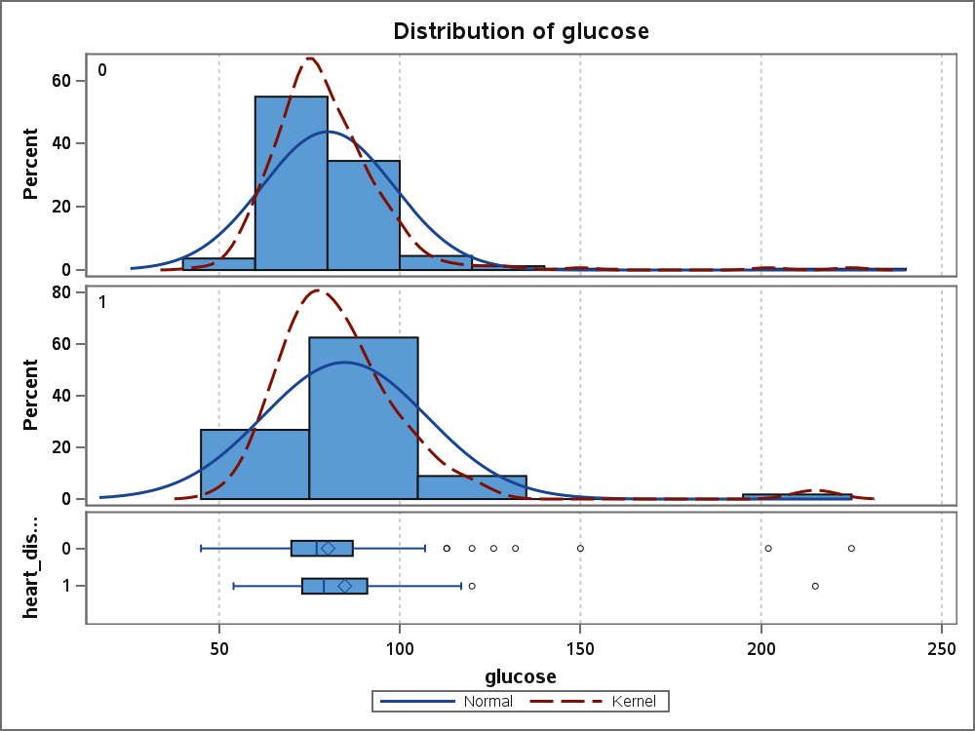
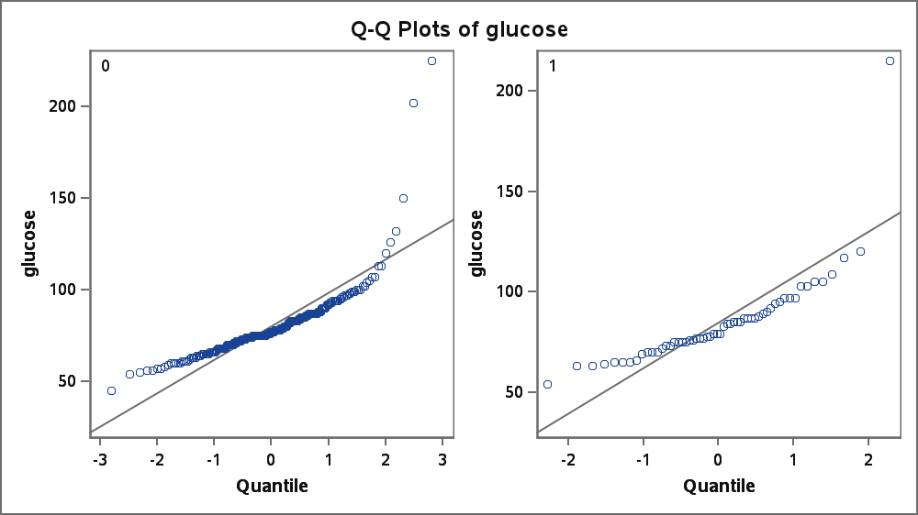

Table of Gender by heart_disease
Gender | heart_disease(Heart Disease Outcome)
Frequency  Expected  Percent  Row Pct  Col Pct | 0 | 1 | Total
Female | 148  146.62  49.01  82.22  60.16 | 32  33.377  10.60  17.78  57.14 | 180  59.60
Male | 98  99.377  32.45  80.33  39.84 | 24  22.623  7.95  19.67  42.86 | 122  40.40
Total | 246  81.46 | 56  18.54 | 302  100.00

Statistics for Table of Gender by heart_disease

Statistic | DF | Value | Prob
Chi-Square | 1 | 0.1728 | 0.6777
Likelihood Ratio Chi-Square | 1 | 0.1720 | 0.6784
Continuity Adj. Chi-Square | 1 | 0.0701 | 0.7912
Mantel-Haenszel Chi-Square | 1 | 0.1722 | 0.6782
Phi Coefficient |  | 0.0239
Contingency Coefficient |  | 0.0239
Cramer's V |  | 0.0239

Fisher's Exact Test
Cell (1,1) Frequency (F) | 148
Left-sided Pr <= F | 0.7158
Right-sided Pr >= F | 0.3935
Table Probability (P) | 0.1093
Two-sided Pr <= P | 0.7631

Sample Size = 302

Table of education by heart_disease
education | heart_disease(Heart Disease Outcome)
Frequency  Expected  Percent  Row Pct  Col Pct | 0 | 1 | Total
graduate | 33  34.212  10.93  78.57  13.41 | 9  7.7881  2.98  21.43  16.07 | 42  13.91
postgraduate | 31  29.325  10.26  86.11  12.60 | 5  6.6755  1.66  13.89  8.93 | 36  11.92
primaryschool | 78  71.682  25.83  88.64  31.71 | 10  16.318  3.31  11.36  17.86 | 88  29.14
uneducated | 104  110.78  34.44  76.47  42.28 | 32  25.219  10.60  23.53  57.14 | 136  45.03
Total | 246  81.46 | 56  18.54 | 302  100.00

Statistics for Table of education by heart_disease

Statistic | DF | Value | Prob
Chi-Square | 3 | 5.9895 | 0.1121
Likelihood Ratio Chi-Square | 3 | 6.2642 | 0.0994
Mantel-Haenszel Chi-Square | 1 | 0.7082 | 0.4001
Phi Coefficient |  | 0.1408
Contingency Coefficient |  | 0.1395
Cramer's V |  | 0.1408

Sample Size = 302

Table of currentSmoker by heart_disease
currentSmoker | heart_disease(Heart Disease Outcome)
Frequency  Expected  Percent  Row Pct  Col Pct | 0 | 1 | Total
0 | 123  127.07  40.73  78.85  50.00 | 33  28.927  10.93  21.15  58.93 | 156  51.66
1 | 123  118.93  40.73  84.25  50.00 | 23  27.073  7.62  15.75  41.07 | 146  48.34
Total | 246  81.46 | 56  18.54 | 302  100.00

Statistics for Table of currentSmoker by heart_disease

Statistic | DF | Value | Prob
Chi-Square | 1 | 1.4562 | 0.2275
Likelihood Ratio Chi-Square | 1 | 1.4641 | 0.2263
Continuity Adj. Chi-Square | 1 | 1.1206 | 0.2898
Mantel-Haenszel Chi-Square | 1 | 1.4514 | 0.2283
Phi Coefficient |  | -0.0694
Contingency Coefficient |  | 0.0693
Cramer's V |  | -0.0694

Fisher's Exact Test
Cell (1,1) Frequency (F) | 123
Left-sided Pr <= F | 0.1448
Right-sided Pr >= F | 0.9126
Table Probability (P) | 0.0574
Two-sided Pr <= P | 0.2396

Sample Size = 302

Table of BPMeds by heart_disease
BPMeds | heart_disease(Heart Disease Outcome)
Frequency  Expected  Percent  Row Pct  Col Pct | 0 | 1 | Total
0 | 239  239.48  79.14  81.29  97.15 | 55  54.517  18.21  18.71  98.21 | 294  97.35
1 | 7  6.5166  2.32  87.50  2.85 | 1  1.4834  0.33  12.50  1.79 | 8  2.65
Total | 246  81.46 | 56  18.54 | 302  100.00

Statistics for Table of BPMeds by heart_disease

Statistic | DF | Value | Prob
Chi-Square | 1 | 0.1987 | 0.6558
Likelihood Ratio Chi-Square | 1 | 0.2184 | 0.6402
Continuity Adj. Chi-Square | 1 | 0.0000 | 1.0000
Mantel-Haenszel Chi-Square | 1 | 0.1980 | 0.6563
Phi Coefficient |  | -0.0256
Contingency Coefficient |  | 0.0256
Cramer's V |  | -0.0256
WARNING: 25% of the cells have expected counts less
than 5. Chi-Square may not be a valid test.

Fisher's Exact Test
Cell (1,1) Frequency (F) | 239
Left-sided Pr <= F | 0.5453
Right-sided Pr >= F | 0.8103
Table Probability (P) | 0.3556
Two-sided Pr <= P | 1.0000

Sample Size = 302

Table of prevalentStroke by heart_disease
prevalentStroke | heart_disease(Heart Disease Outcome)
Frequency  Expected  Percent  Row Pct  Col Pct | 0 | 1 | Total
no | 245  245.19  81.13  81.40  99.59 | 56  55.815  18.54  18.60  100.00 | 301  99.67
yes | 1  0.8146  0.33  100.00  0.41 | 0  0.1854  0.00  0.00  0.00 | 1  0.33
Total | 246  81.46 | 56  18.54 | 302  100.00

Statistics for Table of prevalentStroke by heart_disease

Statistic | DF | Value | Prob
Chi-Square | 1 | 0.2284 | 0.6327
Likelihood Ratio Chi-Square | 1 | 0.4109 | 0.5215
Continuity Adj. Chi-Square | 1 | 0.0000 | 1.0000
Mantel-Haenszel Chi-Square | 1 | 0.2276 | 0.6333
Phi Coefficient |  | -0.0275
Contingency Coefficient |  | 0.0275
Cramer's V |  | -0.0275
WARNING: 50% of the cells have expected counts less
than 5. Chi-Square may not be a valid test.

Fisher's Exact Test
Cell (1,1) Frequency (F) | 245
Left-sided Pr <= F | 0.8146
Right-sided Pr >= F | 1.0000
Table Probability (P) | 0.8146
Two-sided Pr <= P | 1.0000

Sample Size = 302

Table of prevalentHyp by heart_disease
prevalentHyp | heart_disease(Heart Disease Outcome)
Frequency  Expected  Percent  Row Pct  Col Pct | 0 | 1 | Total
0 | 184  171.06  60.93  87.62  74.80 | 26  38.94  8.61  12.38  46.43 | 210  69.54
1 | 62  74.94  20.53  67.39  25.20 | 30  17.06  9.93  32.61  53.57 | 92  30.46
Total | 246  81.46 | 56  18.54 | 302  100.00

Statistics for Table of prevalentHyp by heart_disease

Statistic | DF | Value | Prob
Chi-Square | 1 | 17.3295 | <.0001
Likelihood Ratio Chi-Square | 1 | 16.1950 | <.0001
Continuity Adj. Chi-Square | 1 | 16.0162 | <.0001
Mantel-Haenszel Chi-Square | 1 | 17.2721 | <.0001
Phi Coefficient |  | 0.2395
Contingency Coefficient |  | 0.2330
Cramer's V |  | 0.2395

Fisher's Exact Test
Cell (1,1) Frequency (F) | 184
Left-sided Pr <= F | 1.0000
Right-sided Pr >= F | <.0001
Table Probability (P) | <.0001
Two-sided Pr <= P | <.0001

Sample Size = 302

Table of diabetes by heart_disease
diabetes | heart_disease(Heart Disease Outcome)
Frequency  Expected  Percent  Row Pct  Col Pct | 0 | 1 | Total
0 | 240  238.67  79.47  81.91  97.56 | 53  54.331  17.55  18.09  94.64 | 293  97.02
1 | 6  7.3311  1.99  66.67  2.44 | 3  1.6689  0.99  33.33  5.36 | 9  2.98
Total | 246  81.46 | 56  18.54 | 302  100.00

Statistics for Table of diabetes by heart_disease

Statistic | DF | Value | Prob
Chi-Square | 1 | 1.3435 | 0.2464
Likelihood Ratio Chi-Square | 1 | 1.1546 | 0.2826
Continuity Adj. Chi-Square | 1 | 0.5237 | 0.4692
Mantel-Haenszel Chi-Square | 1 | 1.3390 | 0.2472
Phi Coefficient |  | 0.0667
Contingency Coefficient |  | 0.0665
Cramer's V |  | 0.0667
WARNING: 25% of the cells have expected counts less
than 5. Chi-Square may not be a valid test.

Fisher's Exact Test
Cell (1,1) Frequency (F) | 240
Left-sided Pr <= F | 0.9353
Right-sided Pr >= F | 0.2219
Table Probability (P) | 0.1572
Two-sided Pr <= P | 0.3754

Sample Size = 302

Model Information
Data Set | WORK.HEART_ANALYSIS
Response Variable | heart_disease | Heart Disease Outcome
Number of Response Levels | 2
Model | binary logit
Optimization Technique | Fisher's scoring

Number of Observations Read | 302
Number of Observations Used | 302

Response Profile
Ordered  Value | heart_disease | Total  Frequency
1 | 0 | 246
2 | 1 | 56
Probability modeled is heart_disease=1.

Class Level Information
Class | Value | Design  Variables
prevalentHyp | 0 | 0
 | 1 | 1

Model Convergence Status
Convergence criterion (GCONV=1E-8) satisfied.

Model Fit Statistics
Criterion | Intercept  Only | Intercept  and  Covariates
AIC | 291.635 | 277.440
SC | 295.346 | 284.861
-2 Log L | 289.635 | 273.440

Testing Global Null Hypothesis: BETA=0
Test | Chi-Square | DF | Pr >  ChiSq
Likelihood Ratio | 16.1950 | 1 | <.0001
Score | 17.3295 | 1 | <.0001
Wald | 16.2291 | 1 | <.0001

Type 3 Analysis of Effects
Effect | DF | Wald  Chi-Square | Pr >  ChiSq
prevalentHyp | 1 | 16.2291 | <.0001

Analysis of Maximum Likelihood Estimates
Parameter |  | DF | Estimate | Standard  Error | Wald  Chi-Square | Pr >  ChiSq
Intercept |  | 1 | -1.9568 | 0.2095 | 87.2332 | <.0001
prevalentHyp | 1 | 1 | 1.2309 | 0.3055 | 16.2291 | <.0001

Odds Ratio Estimates
Effect | Point  Estimate | 95% Wald  Confidence Limits
prevalentHyp 1 vs 0 | 3.424 | 1.881 | 6.232

Association of Predicted Probabilities and Observed Responses
Percent Concordant | 40.1 | Somers' D | 0.284
Percent Discordant | 11.7 | Gamma | 0.548
Percent Tied | 48.2 | Tau-a | 0.086
Pairs | 13776 | c | 0.642

Model Information
Data Set | WORK.HEART_ANALYSIS
Response Variable | heart_disease | Heart Disease Outcome
Number of Response Levels | 2
Model | binary logit
Optimization Technique | Fisher's scoring

Number of Observations Read | 302
Number of Observations Used | 302

Response Profile
Ordered  Value | heart_disease | Total  Frequency
1 | 0 | 246
2 | 1 | 56
Probability modeled is heart_disease=1.

Model Convergence Status
Convergence criterion (GCONV=1E-8) satisfied.

Model Fit Statistics
Criterion | Intercept  Only | Intercept  and  Covariates
AIC | 291.635 | 272.131
SC | 295.346 | 279.551
-2 Log L | 289.635 | 268.131

Testing Global Null Hypothesis: BETA=0
Test | Chi-Square | DF | Pr >  ChiSq
Likelihood Ratio | 21.5048 | 1 | <.0001
Score | 21.1802 | 1 | <.0001
Wald | 19.4902 | 1 | <.0001

Analysis of Maximum Likelihood Estimates
Parameter | DF | Estimate | Standard  Error | Wald  Chi-Square | Pr >  ChiSq
Intercept | 1 | -5.6810 | 0.9964 | 32.5103 | <.0001
age | 1 | 0.0811 | 0.0184 | 19.4902 | <.0001

Odds Ratio Estimates
Effect | Point  Estimate | 95% Wald  Confidence Limits
age | 1.085 | 1.046 | 1.124

Association of Predicted Probabilities and Observed Responses
Percent Concordant | 67.7 | Somers' D | 0.382
Percent Discordant | 29.5 | Gamma | 0.393
Percent Tied | 2.8 | Tau-a | 0.116
Pairs | 13776 | c | 0.691

Model Information
Data Set | WORK.HEART_ANALYSIS
Response Variable | heart_disease | Heart Disease Outcome
Number of Response Levels | 2
Model | binary logit
Optimization Technique | Fisher's scoring

Number of Observations Read | 302
Number of Observations Used | 302

Response Profile
Ordered  Value | heart_disease | Total  Frequency
1 | 0 | 246
2 | 1 | 56
Probability modeled is heart_disease=1.

Model Convergence Status
Convergence criterion (GCONV=1E-8) satisfied.

Model Fit Statistics
Criterion | Intercept  Only | Intercept  and  Covariates
AIC | 291.635 | 293.599
SC | 295.346 | 301.020
-2 Log L | 289.635 | 289.599

Testing Global Null Hypothesis: BETA=0
Test | Chi-Square | DF | Pr >  ChiSq
Likelihood Ratio | 0.0362 | 1 | 0.8492
Score | 0.0359 | 1 | 0.8497
Wald | 0.0359 | 1 | 0.8498

Analysis of Maximum Likelihood Estimates
Parameter | DF | Estimate | Standard  Error | Wald  Chi-Square | Pr >  ChiSq
Intercept | 1 | -1.4591 | 0.1838 | 63.0276 | <.0001
cigsPerDay | 1 | -0.00228 | 0.0120 | 0.0359 | 0.8498

Odds Ratio Estimates
Effect | Point  Estimate | 95% Wald  Confidence Limits
cigsPerDay | 0.998 | 0.975 | 1.021

Association of Predicted Probabilities and Observed Responses
Percent Concordant | 35.9 | Somers' D | 0.052
Percent Discordant | 30.7 | Gamma | 0.078
Percent Tied | 33.4 | Tau-a | 0.016
Pairs | 13776 | c | 0.526

Model Information
Data Set | WORK.HEART_ANALYSIS
Response Variable | heart_disease | Heart Disease Outcome
Number of Response Levels | 2
Model | binary logit
Optimization Technique | Fisher's scoring

Number of Observations Read | 302
Number of Observations Used | 302

Response Profile
Ordered  Value | heart_disease | Total  Frequency
1 | 0 | 246
2 | 1 | 56
Probability modeled is heart_disease=1.

Model Convergence Status
Convergence criterion (GCONV=1E-8) satisfied.

Model Fit Statistics
Criterion | Intercept  Only | Intercept  and  Covariates
AIC | 291.635 | 284.022
SC | 295.346 | 291.443
-2 Log L | 289.635 | 280.022

Testing Global Null Hypothesis: BETA=0
Test | Chi-Square | DF | Pr >  ChiSq
Likelihood Ratio | 9.6133 | 1 | 0.0019
Score | 9.9062 | 1 | 0.0016
Wald | 9.2495 | 1 | 0.0024

Analysis of Maximum Likelihood Estimates
Parameter | DF | Estimate | Standard  Error | Wald  Chi-Square | Pr >  ChiSq
Intercept | 1 | -3.9783 | 0.8532 | 21.7421 | <.0001
totChol | 1 | 0.0102 | 0.00335 | 9.2495 | 0.0024

Odds Ratio Estimates
Effect | Point  Estimate | 95% Wald  Confidence Limits
totChol | 1.010 | 1.004 | 1.017

Association of Predicted Probabilities and Observed Responses
Percent Concordant | 61.6 | Somers' D | 0.238
Percent Discordant | 37.8 | Gamma | 0.240
Percent Tied | 0.7 | Tau-a | 0.072
Pairs | 13776 | c | 0.619

Model Information
Data Set | WORK.HEART_ANALYSIS
Response Variable | heart_disease | Heart Disease Outcome
Number of Response Levels | 2
Model | binary logit
Optimization Technique | Fisher's scoring

Number of Observations Read | 302
Number of Observations Used | 302

Response Profile
Ordered  Value | heart_disease | Total  Frequency
1 | 0 | 246
2 | 1 | 56
Probability modeled is heart_disease=1.

Model Convergence Status
Convergence criterion (GCONV=1E-8) satisfied.

Model Fit Statistics
Criterion | Intercept  Only | Intercept  and  Covariates
AIC | 291.635 | 279.745
SC | 295.346 | 287.165
-2 Log L | 289.635 | 275.745

Testing Global Null Hypothesis: BETA=0
Test | Chi-Square | DF | Pr >  ChiSq
Likelihood Ratio | 13.8908 | 1 | 0.0002
Score | 14.9081 | 1 | 0.0001
Wald | 13.7796 | 1 | 0.0002

Analysis of Maximum Likelihood Estimates
Parameter | DF | Estimate | Standard  Error | Wald  Chi-Square | Pr >  ChiSq
Intercept | 1 | -4.6298 | 0.8818 | 27.5649 | <.0001
sysBP | 1 | 0.0231 | 0.00622 | 13.7796 | 0.0002

Odds Ratio Estimates
Effect | Point  Estimate | 95% Wald  Confidence Limits
sysBP | 1.023 | 1.011 | 1.036

Association of Predicted Probabilities and Observed Responses
Percent Concordant | 65.9 | Somers' D | 0.328
Percent Discordant | 33.1 | Gamma | 0.331
Percent Tied | 1.0 | Tau-a | 0.099
Pairs | 13776 | c | 0.664

Model Information
Data Set | WORK.HEART_ANALYSIS
Response Variable | heart_disease | Heart Disease Outcome
Number of Response Levels | 2
Model | binary logit
Optimization Technique | Fisher's scoring

Number of Observations Read | 302
Number of Observations Used | 302

Response Profile
Ordered  Value | heart_disease | Total  Frequency
1 | 0 | 246
2 | 1 | 56
Probability modeled is heart_disease=1.

Model Convergence Status
Convergence criterion (GCONV=1E-8) satisfied.

Model Fit Statistics
Criterion | Intercept  Only | Intercept  and  Covariates
AIC | 291.635 | 282.811
SC | 295.346 | 290.231
-2 Log L | 289.635 | 278.811

Testing Global Null Hypothesis: BETA=0
Test | Chi-Square | DF | Pr >  ChiSq
Likelihood Ratio | 10.8248 | 1 | 0.0010
Score | 11.1906 | 1 | 0.0008
Wald | 10.5945 | 1 | 0.0011

Analysis of Maximum Likelihood Estimates
Parameter | DF | Estimate | Standard  Error | Wald  Chi-Square | Pr >  ChiSq
Intercept | 1 | -4.8859 | 1.0766 | 20.5944 | <.0001
diaBP | 1 | 0.0405 | 0.0124 | 10.5945 | 0.0011

Odds Ratio Estimates
Effect | Point  Estimate | 95% Wald  Confidence Limits
diaBP | 1.041 | 1.016 | 1.067

Association of Predicted Probabilities and Observed Responses
Percent Concordant | 62.7 | Somers' D | 0.271
Percent Discordant | 35.6 | Gamma | 0.276
Percent Tied | 1.7 | Tau-a | 0.082
Pairs | 13776 | c | 0.636

Model Information
Data Set | WORK.HEART_ANALYSIS
Response Variable | heart_disease | Heart Disease Outcome
Number of Response Levels | 2
Model | binary logit
Optimization Technique | Fisher's scoring

Number of Observations Read | 302
Number of Observations Used | 302

Response Profile
Ordered  Value | heart_disease | Total  Frequency
1 | 0 | 246
2 | 1 | 56
Probability modeled is heart_disease=1.

Model Convergence Status
Convergence criterion (GCONV=1E-8) satisfied.

Model Fit Statistics
Criterion | Intercept  Only | Intercept  and  Covariates
AIC | 291.635 | 289.800
SC | 295.346 | 297.221
-2 Log L | 289.635 | 285.800

Testing Global Null Hypothesis: BETA=0
Test | Chi-Square | DF | Pr >  ChiSq
Likelihood Ratio | 3.8349 | 1 | 0.0502
Score | 4.0604 | 1 | 0.0439
Wald | 3.9473 | 1 | 0.0469

Analysis of Maximum Likelihood Estimates
Parameter | DF | Estimate | Standard  Error | Wald  Chi-Square | Pr >  ChiSq
Intercept | 1 | -3.1098 | 0.8449 | 13.5463 | 0.0002
BMI | 1 | 0.0620 | 0.0312 | 3.9473 | 0.0469

Odds Ratio Estimates
Effect | Point  Estimate | 95% Wald  Confidence Limits
BMI | 1.064 | 1.001 | 1.131

Association of Predicted Probabilities and Observed Responses
Percent Concordant | 58.4 | Somers' D | 0.169
Percent Discordant | 41.5 | Gamma | 0.169
Percent Tied | 0.1 | Tau-a | 0.051
Pairs | 13776 | c | 0.584

Model Information
Data Set | WORK.HEART_ANALYSIS
Response Variable | heart_disease | Heart Disease Outcome
Number of Response Levels | 2
Model | binary logit
Optimization Technique | Fisher's scoring

Number of Observations Read | 302
Number of Observations Used | 302

Response Profile
Ordered  Value | heart_disease | Total  Frequency
1 | 0 | 246
2 | 1 | 56
Probability modeled is heart_disease=1.

Model Convergence Status
Convergence criterion (GCONV=1E-8) satisfied.

Model Fit Statistics
Criterion | Intercept  Only | Intercept  and  Covariates
AIC | 291.635 | 293.442
SC | 295.346 | 300.863
-2 Log L | 289.635 | 289.442

Testing Global Null Hypothesis: BETA=0
Test | Chi-Square | DF | Pr >  ChiSq
Likelihood Ratio | 0.1930 | 1 | 0.6604
Score | 0.1911 | 1 | 0.6620
Wald | 0.1910 | 1 | 0.6621

Analysis of Maximum Likelihood Estimates
Parameter | DF | Estimate | Standard  Error | Wald  Chi-Square | Pr >  ChiSq
Intercept | 1 | -1.0688 | 0.9494 | 1.2674 | 0.2603
heartRate | 1 | -0.00547 | 0.0125 | 0.1910 | 0.6621

Odds Ratio Estimates
Effect | Point  Estimate | 95% Wald  Confidence Limits
heartRate | 0.995 | 0.970 | 1.019

Association of Predicted Probabilities and Observed Responses
Percent Concordant | 49.0 | Somers' D | 0.034
Percent Discordant | 45.6 | Gamma | 0.036
Percent Tied | 5.4 | Tau-a | 0.010
Pairs | 13776 | c | 0.517

Model Information
Data Set | WORK.HEART_ANALYSIS
Response Variable | heart_disease | Heart Disease Outcome
Number of Response Levels | 2
Model | binary logit
Optimization Technique | Fisher's scoring

Number of Observations Read | 302
Number of Observations Used | 302

Response Profile
Ordered  Value | heart_disease | Total  Frequency
1 | 0 | 246
2 | 1 | 56
Probability modeled is heart_disease=1.

Model Convergence Status
Convergence criterion (GCONV=1E-8) satisfied.

Model Fit Statistics
Criterion | Intercept  Only | Intercept  and  Covariates
AIC | 291.635 | 291.296
SC | 295.346 | 298.717
-2 Log L | 289.635 | 287.296

Testing Global Null Hypothesis: BETA=0
Test | Chi-Square | DF | Pr >  ChiSq
Likelihood Ratio | 2.3390 | 1 | 0.1262
Score | 2.6816 | 1 | 0.1015
Wald | 2.4735 | 1 | 0.1158

Analysis of Maximum Likelihood Estimates
Parameter | DF | Estimate | Standard  Error | Wald  Chi-Square | Pr >  ChiSq
Intercept | 1 | -2.3462 | 0.5768 | 16.5442 | <.0001
glucose | 1 | 0.0105 | 0.00670 | 2.4735 | 0.1158

Odds Ratio Estimates
Effect | Point  Estimate | 95% Wald  Confidence Limits
glucose | 1.011 | 0.997 | 1.024

Association of Predicted Probabilities and Observed Responses
Percent Concordant | 56.2 | Somers' D | 0.152
Percent Discordant | 41.1 | Gamma | 0.156
Percent Tied | 2.7 | Tau-a | 0.046
Pairs | 13776 | c | 0.576

Model Information
Data Set | WORK.HEART_ANALYSIS
Response Variable | heart_disease | Heart Disease Outcome
Number of Response Levels | 2
Model | binary logit
Optimization Technique | Fisher's scoring

Number of Observations Read | 302
Number of Observations Used | 302

Response Profile
Ordered  Value | heart_disease | Total  Frequency
1 | 1 | 56
2 | 0 | 246
Probability modeled is heart_disease=1.

Model Convergence Status
Convergence criterion (GCONV=1E-8) satisfied.

Model Fit Statistics
Criterion | Intercept  Only | Intercept  and  Covariates
AIC | 291.635 | 270.349
SC | 295.346 | 300.033
-2 Log L | 289.635 | 254.349

Testing Global Null Hypothesis: BETA=0
Test | Chi-Square | DF | Pr >  ChiSq
Likelihood Ratio | 35.2862 | 7 | <.0001
Score | 34.3061 | 7 | <.0001
Wald | 29.6974 | 7 | 0.0001

Analysis of Maximum Likelihood Estimates
Parameter | DF | Estimate | Standard  Error | Wald  Chi-Square | Pr >  ChiSq
Intercept | 1 | -8.1804 | 1.9817 | 17.0398 | <.0001
age | 1 | 0.0666 | 0.0213 | 9.8264 | 0.0017
totChol | 1 | 0.00777 | 0.00359 | 4.6942 | 0.0303
sysBP | 1 | -0.00970 | 0.0125 | 0.5999 | 0.4386
diaBP | 1 | 0.0278 | 0.0232 | 1.4281 | 0.2321
BMI | 1 | -0.0129 | 0.0385 | 0.1119 | 0.7379
glucose | 1 | 0.00441 | 0.00754 | 0.3422 | 0.5585
prevalentHyp | 1 | 0.7666 | 0.4404 | 3.0296 | 0.0818

Association of Predicted Probabilities and Observed Responses
Percent Concordant | 74.8 | Somers' D | 0.496
Percent Discordant | 25.2 | Gamma | 0.496
Percent Tied | 0.0 | Tau-a | 0.150
Pairs | 13776 | c | 0.748

Odds Ratio Estimates and Wald Confidence Intervals
Effect | Unit | Estimate | 95% Confidence Limits
age | 1.0000 | 1.069 | 1.025 | 1.114
totChol | 1.0000 | 1.008 | 1.001 | 1.015
sysBP | 1.0000 | 0.990 | 0.966 | 1.015
diaBP | 1.0000 | 1.028 | 0.982 | 1.076
BMI | 1.0000 | 0.987 | 0.916 | 1.065
glucose | 1.0000 | 1.004 | 0.990 | 1.019
prevalentHyp | 1.0000 | 2.152 | 0.908 | 5.103

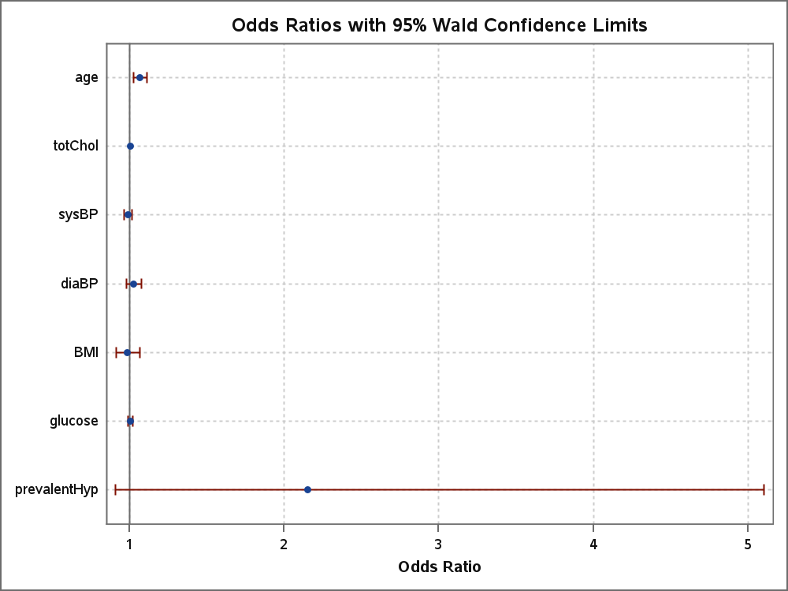

Model Information
Data Set | WORK.HEART_ANALYSIS
Response Variable | heart_disease | Heart Disease Outcome
Number of Response Levels | 2
Model | binary logit
Optimization Technique | Fisher's scoring

Number of Observations Read | 302
Number of Observations Used | 302

Response Profile
Ordered  Value | heart_disease | Total  Frequency
1 | 1 | 56
2 | 0 | 246
Probability modeled is heart_disease=1.

Model Convergence Status
Convergence criterion (GCONV=1E-8) satisfied.

Model Fit Statistics
Criterion | Intercept  Only | Intercept  and  Covariates
AIC | 291.635 | 270.349
SC | 295.346 | 300.033
-2 Log L | 289.635 | 254.349

R-Square | 0.1103 | Max-rescaled R-Square | 0.1788

Testing Global Null Hypothesis: BETA=0
Test | Chi-Square | DF | Pr >  ChiSq
Likelihood Ratio | 35.2862 | 7 | <.0001
Score | 34.3061 | 7 | <.0001
Wald | 29.6974 | 7 | 0.0001

Analysis of Maximum Likelihood Estimates
Parameter | DF | Estimate | Standard  Error | Wald  Chi-Square | Pr >  ChiSq
Intercept | 1 | -8.1804 | 1.9817 | 17.0398 | <.0001
age | 1 | 0.0666 | 0.0213 | 9.8264 | 0.0017
totChol | 1 | 0.00777 | 0.00359 | 4.6942 | 0.0303
sysBP | 1 | -0.00970 | 0.0125 | 0.5999 | 0.4386
diaBP | 1 | 0.0278 | 0.0232 | 1.4281 | 0.2321
BMI | 1 | -0.0129 | 0.0385 | 0.1119 | 0.7379
glucose | 1 | 0.00441 | 0.00754 | 0.3422 | 0.5585
prevalentHyp | 1 | 0.7666 | 0.4404 | 3.0296 | 0.0818

Association of Predicted Probabilities and Observed Responses
Percent Concordant | 74.8 | Somers' D | 0.496
Percent Discordant | 25.2 | Gamma | 0.496
Percent Tied | 0.0 | Tau-a | 0.150
Pairs | 13776 | c | 0.748

Odds Ratio Estimates and Wald Confidence Intervals
Effect | Unit | Estimate | 95% Confidence Limits
age | 1.0000 | 1.069 | 1.025 | 1.114
totChol | 1.0000 | 1.008 | 1.001 | 1.015
sysBP | 1.0000 | 0.990 | 0.966 | 1.015
diaBP | 1.0000 | 1.028 | 0.982 | 1.076
BMI | 1.0000 | 0.987 | 0.916 | 1.065
glucose | 1.0000 | 1.004 | 0.990 | 1.019
prevalentHyp | 1.0000 | 2.152 | 0.908 | 5.103



Partition for the Hosmer and Lemeshow Test
Group | Total | heart_disease = 1 |  | heart_disease = 0
 |  | Observed | Expected | Observed | Expected
1 | 30 | 0 | 1.11 | 30 | 28.89
2 | 30 | 1 | 1.75 | 29 | 28.25
3 | 30 | 2 | 2.38 | 28 | 27.62
4 | 30 | 2 | 3.12 | 28 | 26.88
5 | 30 | 6 | 3.86 | 24 | 26.14
6 | 30 | 8 | 4.79 | 22 | 25.21
7 | 30 | 6 | 6.00 | 24 | 24.00
8 | 30 | 7 | 7.54 | 23 | 22.46
9 | 30 | 10 | 10.05 | 20 | 19.95
10 | 32 | 14 | 15.38 | 18 | 16.62

Hosmer and Lemeshow Goodness-of-Fit Test
Chi-Square | DF | Pr > ChiSq
6.2327 | 8 | 0.6212

Model Information
Data Set | WORK.HEART_ANALYSIS
Response Variable | heart_disease | Heart Disease Outcome
Number of Response Levels | 2
Model | binary logit
Optimization Technique | Fisher's scoring

Number of Observations Read | 302
Number of Observations Used | 302

Response Profile
Ordered  Value | heart_disease | Total  Frequency
1 | 1 | 56
2 | 0 | 246
Probability modeled is heart_disease=1.

Model Convergence Status
Convergence criterion (GCONV=1E-8) satisfied.

Model Fit Statistics
Criterion | Intercept  Only | Intercept  and  Covariates
AIC | 291.635 | 270.349
SC | 295.346 | 300.033
-2 Log L | 289.635 | 254.349

R-Square | 0.1103 | Max-rescaled R-Square | 0.1788

Testing Global Null Hypothesis: BETA=0
Test | Chi-Square | DF | Pr >  ChiSq
Likelihood Ratio | 35.2862 | 7 | <.0001
Score | 34.3061 | 7 | <.0001
Wald | 29.6974 | 7 | 0.0001

Analysis of Maximum Likelihood Estimates
Parameter | DF | Estimate | Standard  Error | Wald  Chi-Square | Pr >  ChiSq
Intercept | 1 | -8.1804 | 1.9817 | 17.0398 | <.0001
age | 1 | 0.0666 | 0.0213 | 9.8264 | 0.0017
totChol | 1 | 0.00777 | 0.00359 | 4.6942 | 0.0303
sysBP | 1 | -0.00970 | 0.0125 | 0.5999 | 0.4386
diaBP | 1 | 0.0278 | 0.0232 | 1.4281 | 0.2321
BMI | 1 | -0.0129 | 0.0385 | 0.1119 | 0.7379
glucose | 1 | 0.00441 | 0.00754 | 0.3422 | 0.5585
prevalentHyp | 1 | 0.7666 | 0.4404 | 3.0296 | 0.0818

Association of Predicted Probabilities and Observed Responses
Percent Concordant | 74.8 | Somers' D | 0.496
Percent Discordant | 25.2 | Gamma | 0.496
Percent Tied | 0.0 | Tau-a | 0.150
Pairs | 13776 | c | 0.748

Odds Ratio Estimates and Wald Confidence Intervals
Effect | Unit | Estimate | 95% Confidence Limits
age | 1.0000 | 1.069 | 1.025 | 1.114
totChol | 1.0000 | 1.008 | 1.001 | 1.015
sysBP | 1.0000 | 0.990 | 0.966 | 1.015
diaBP | 1.0000 | 1.028 | 0.982 | 1.076
BMI | 1.0000 | 0.987 | 0.916 | 1.065
glucose | 1.0000 | 1.004 | 0.990 | 1.019
prevalentHyp | 1.0000 | 2.152 | 0.908 | 5.103



Partition for the Hosmer and Lemeshow Test
Group | Total | heart_disease = 1 |  | heart_disease = 0
 |  | Observed | Expected | Observed | Expected
1 | 30 | 0 | 1.11 | 30 | 28.89
2 | 30 | 1 | 1.75 | 29 | 28.25
3 | 30 | 2 | 2.38 | 28 | 27.62
4 | 30 | 2 | 3.12 | 28 | 26.88
5 | 30 | 6 | 3.86 | 24 | 26.14
6 | 30 | 8 | 4.79 | 22 | 25.21
7 | 30 | 6 | 6.00 | 24 | 24.00
8 | 30 | 7 | 7.54 | 23 | 22.46
9 | 30 | 10 | 10.05 | 20 | 19.95
10 | 32 | 14 | 15.38 | 18 | 16.62

Hosmer and Lemeshow Goodness-of-Fit Test
Chi-Square | DF | Pr > ChiSq
6.2327 | 8 | 0.6212

Number of Observations Read | 302
Number of Observations Used | 302

Analysis of Variance
Source | DF | Sum of  Squares | Mean  Square | F Value | Pr > F
Model | 6 | 4.64171 | 0.77362 | 5.57 | <.0001
Error | 295 | 40.97419 | 0.13890
Corrected Total | 301 | 45.61589

Root MSE | 0.37269 | R-Square | 0.1018
Dependent Mean | 0.18543 | Adj R-Sq | 0.0835
Coeff Var | 200.98474

Parameter Estimates
Variable | Label | DF | Parameter  Estimate | Standard  Error | t Value | Pr > |t| | Tolerance | Variance  Inflation
Intercept | Intercept | 1 | -0.88343 | 0.21022 | -4.20 | <.0001 | . | 0
age | Age (years) | 1 | 0.00866 | 0.00286 | 3.03 | 0.0027 | 0.73138 | 1.36727
totChol |  | 1 | 0.00102 | 0.00050158 | 2.02 | 0.0438 | 0.92295 | 1.08348
sysBP | Systolic Blood Pressure | 1 | 0.00030715 | 0.00173 | 0.18 | 0.8591 | 0.29814 | 3.35413
diaBP | Diastolic Blood Pressure | 1 | 0.00401 | 0.00316 | 1.27 | 0.2055 | 0.33036 | 3.02702
BMI |  | 1 | -0.00127 | 0.00556 | -0.23 | 0.8195 | 0.75019 | 1.33299
glucose |  | 1 | 0.00067985 | 0.00120 | 0.57 | 0.5709 | 0.87465 | 1.14331

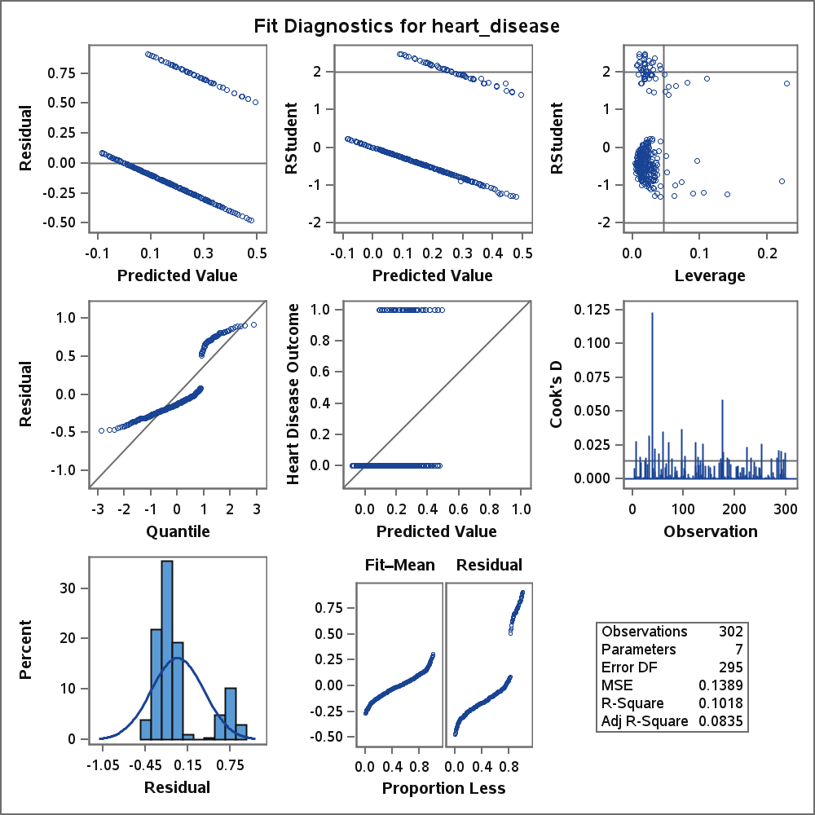
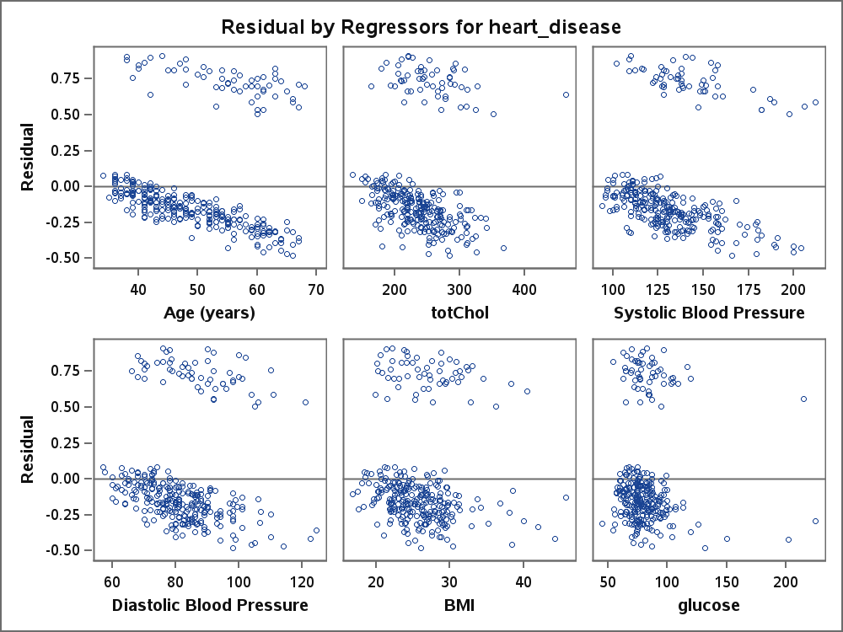

6 Variables: | age totChol sysBP diaBP BMI glucose

Simple Statistics
Variable | N | Mean | Std Dev | Sum | Minimum | Maximum | Label
age | 302 | 49.87748 | 8.79302 | 15063 | 34.00000 | 68.00000 | Age (years)
totChol | 302 | 239.51656 | 44.57937 | 72334 | 135.00000 | 464.00000
sysBP | 302 | 132.88411 | 22.75786 | 40131 | 94.00000 | 212.00000 | Systolic Blood Pressure
diaBP | 302 | 82.43709 | 11.81598 | 24896 | 57.00000 | 124.50000 | Diastolic Blood Pressure
BMI | 302 | 25.91930 | 4.45790 | 7828 | 16.75000 | 45.80000
glucose | 302 | 81.00662 | 19.16635 | 24464 | 45.00000 | 225.00000

Pearson Correlation Coefficients, N = 302
Prob > |r| under H0: Rho=0
 | age | totChol | sysBP | diaBP | BMI | glucose
age  Age (years) | 1.00000 | 0.25751  <.0001 | 0.43658  <.0001 | 0.23222  <.0001 | 0.23293  <.0001 | 0.19656  0.0006
totChol | 0.25751  <.0001 | 1.00000 | 0.16431  0.0042 | 0.10844  0.0598 | 0.12333  0.0321 | 0.00314  0.9567
sysBP  Systolic Blood Pressure | 0.43658  <.0001 | 0.16431  0.0042 | 1.00000 | 0.78391  <.0001 | 0.39294  <.0001 | 0.29780  <.0001
diaBP  Diastolic Blood Pressure | 0.23222  <.0001 | 0.10844  0.0598 | 0.78391  <.0001 | 1.00000 | 0.46624  <.0001 | 0.16046  0.0052
BMI | 0.23293  <.0001 | 0.12333  0.0321 | 0.39294  <.0001 | 0.46624  <.0001 | 1.00000 | 0.20204  0.0004
glucose | 0.19656  0.0006 | 0.00314  0.9567 | 0.29780  <.0001 | 0.16046  0.0052 | 0.20204  0.0004 | 1.00000

Model Information
Data Set | WORK.HEART_ANALYSIS
Response Variable | heart_disease | Heart Disease Outcome
Number of Response Levels | 2
Model | binary logit
Optimization Technique | Fisher's scoring

Number of Observations Read | 302
Number of Observations Used | 302

Response Profile
Ordered  Value | heart_disease | Total  Frequency
1 | 1 | 56
2 | 0 | 246
Probability modeled is heart_disease=1.

Model Convergence Status
Convergence criterion (GCONV=1E-8) satisfied.

Model Fit Statistics
Criterion | Intercept  Only | Intercept  and  Covariates
AIC | 291.635 | 263.929
SC | 295.346 | 278.770
-2 Log L | 289.635 | 255.929

R-Square | 0.1056 | Max-rescaled R-Square | 0.1712

Testing Global Null Hypothesis: BETA=0
Test | Chi-Square | DF | Pr >  ChiSq
Likelihood Ratio | 33.7066 | 3 | <.0001
Score | 33.3890 | 3 | <.0001
Wald | 29.1211 | 3 | <.0001

Analysis of Maximum Likelihood Estimates
Parameter | DF | Estimate | Standard  Error | Wald  Chi-Square | Pr >  ChiSq
Intercept | 1 | -6.7956 | 1.2780 | 28.2749 | <.0001
age | 1 | 0.0611 | 0.0193 | 9.9556 | 0.0016
totChol | 1 | 0.00735 | 0.00357 | 4.2435 | 0.0394
prevalentHyp | 1 | 0.8898 | 0.3246 | 7.5117 | 0.0061

Association of Predicted Probabilities and Observed Responses
Percent Concordant | 75.2 | Somers' D | 0.503
Percent Discordant | 24.8 | Gamma | 0.503
Percent Tied | 0.0 | Tau-a | 0.153
Pairs | 13776 | c | 0.752

Odds Ratio Estimates and Wald Confidence Intervals
Effect | Unit | Estimate | 95% Confidence Limits
age | 1.0000 | 1.063 | 1.023 | 1.104
totChol | 1.0000 | 1.007 | 1.000 | 1.014
prevalentHyp | 1.0000 | 2.435 | 1.289 | 4.600

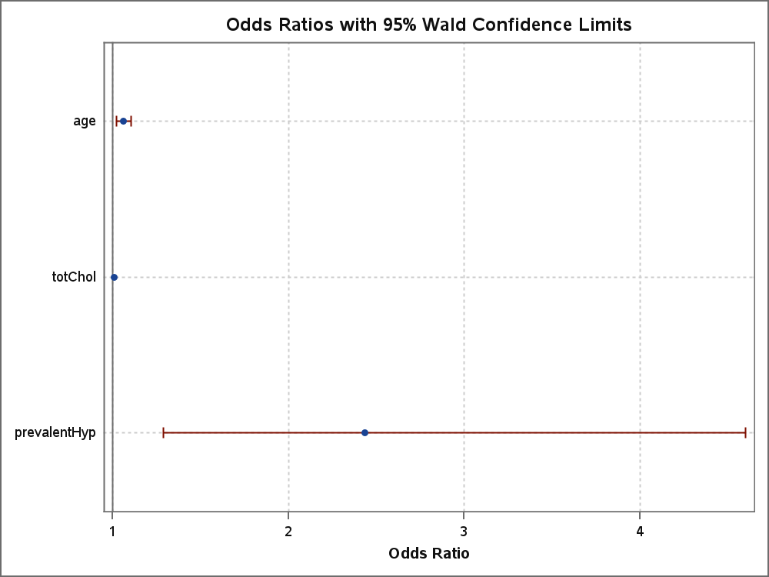

Partition for the Hosmer and Lemeshow Test
Group | Total | heart_disease = 1 |  | heart_disease = 0
 |  | Observed | Expected | Observed | Expected
1 | 30 | 0 | 1.29 | 30 | 28.71
2 | 30 | 1 | 1.87 | 29 | 28.13
3 | 30 | 3 | 2.43 | 27 | 27.57
4 | 30 | 0 | 3.15 | 30 | 26.85
5 | 30 | 5 | 3.87 | 25 | 26.13
6 | 30 | 9 | 4.84 | 21 | 25.16
7 | 30 | 7 | 5.87 | 23 | 24.13
8 | 30 | 4 | 7.50 | 26 | 22.50
9 | 30 | 16 | 9.80 | 14 | 20.20
10 | 32 | 11 | 15.39 | 21 | 16.61

Hosmer and Lemeshow Goodness-of-Fit Test
Chi-Square | DF | Pr > ChiSq
20.7801 | 8 | 0.0078

Model Information
Data Set | WORK.HEART_ANALYSIS
Response Variable | heart_disease | Heart Disease Outcome
Number of Response Levels | 2
Model | binary logit
Optimization Technique | Fisher's scoring

Number of Observations Read | 302
Number of Observations Used | 302

Response Profile
Ordered  Value | heart_disease | Total  Frequency
1 | 1 | 56
2 | 0 | 246
Probability modeled is heart_disease=1.

Model Convergence Status
Convergence criterion (GCONV=1E-8) satisfied.

Model Fit Statistics
Criterion | Intercept  Only | Intercept  and  Covariates
AIC | 291.635 | 266.747
SC | 295.346 | 289.009
-2 Log L | 289.635 | 254.747

R-Square | 0.1091 | Max-rescaled R-Square | 0.1769

Testing Global Null Hypothesis: BETA=0
Test | Chi-Square | DF | Pr >  ChiSq
Likelihood Ratio | 34.8888 | 5 | <.0001
Score | 33.9603 | 5 | <.0001
Wald | 29.4705 | 5 | <.0001

Analysis of Maximum Likelihood Estimates
Parameter | DF | Estimate | Standard  Error | Wald  Chi-Square | Pr >  ChiSq
Intercept | 1 | -7.9990 | 1.8665 | 18.3669 | <.0001
age | 1 | 0.0660 | 0.0210 | 9.8401 | 0.0017
totChol | 1 | 0.00751 | 0.00357 | 4.4257 | 0.0354
prevalentHyp | 1 | 0.7620 | 0.4372 | 3.0374 | 0.0814
sysBP | 1 | -0.00758 | 0.0121 | 0.3957 | 0.5293
diaBP | 1 | 0.0236 | 0.0219 | 1.1653 | 0.2804

Association of Predicted Probabilities and Observed Responses
Percent Concordant | 74.8 | Somers' D | 0.495
Percent Discordant | 25.2 | Gamma | 0.495
Percent Tied | 0.0 | Tau-a | 0.150
Pairs | 13776 | c | 0.748

Odds Ratio Estimates and Wald Confidence Intervals
Effect | Unit | Estimate | 95% Confidence Limits
age | 1.0000 | 1.068 | 1.025 | 1.113
totChol | 1.0000 | 1.008 | 1.001 | 1.015
prevalentHyp | 1.0000 | 2.143 | 0.909 | 5.048
sysBP | 1.0000 | 0.992 | 0.969 | 1.016
diaBP | 1.0000 | 1.024 | 0.981 | 1.069

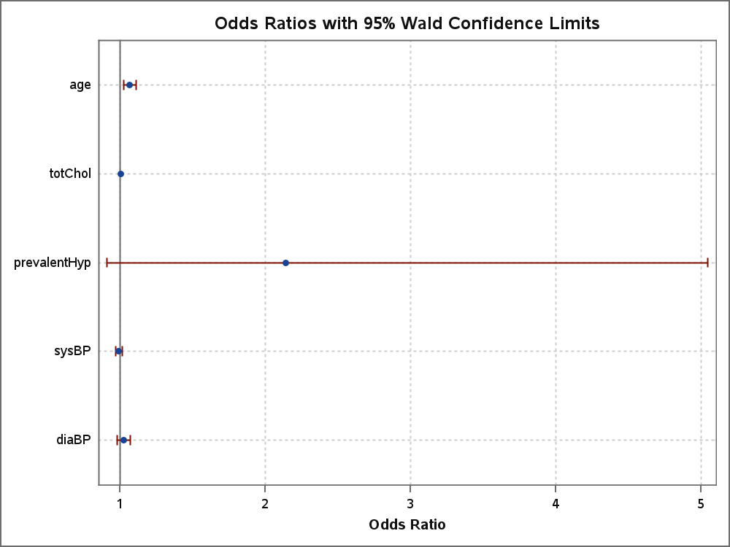

Partition for the Hosmer and Lemeshow Test
Group | Total | heart_disease = 1 |  | heart_disease = 0
 |  | Observed | Expected | Observed | Expected
1 | 30 | 0 | 1.13 | 30 | 28.87
2 | 30 | 2 | 1.79 | 28 | 28.21
3 | 30 | 1 | 2.35 | 29 | 27.65
4 | 30 | 1 | 3.13 | 29 | 26.87
5 | 30 | 7 | 3.90 | 23 | 26.10
6 | 30 | 8 | 4.85 | 22 | 25.15
7 | 30 | 6 | 6.01 | 24 | 23.99
8 | 30 | 7 | 7.47 | 23 | 22.53
9 | 30 | 10 | 9.99 | 20 | 20.01
10 | 32 | 14 | 15.37 | 18 | 16.63

Hosmer and Lemeshow Goodness-of-Fit Test
Chi-Square | DF | Pr > ChiSq
9.2021 | 8 | 0.3255

Model Information
Data Set | WORK.HEART_ANALYSIS
Response Variable | heart_disease | Heart Disease Outcome
Number of Response Levels | 2
Model | binary logit
Optimization Technique | Fisher's scoring

Number of Observations Read | 302
Number of Observations Used | 302

Response Profile
Ordered  Value | heart_disease | Total  Frequency
1 | 1 | 56
2 | 0 | 246
Probability modeled is heart_disease=1.

Model Convergence Status
Convergence criterion (GCONV=1E-8) satisfied.

Model Fit Statistics
Criterion | Intercept  Only | Intercept  and  Covariates
AIC | 291.635 | 266.747
SC | 295.346 | 289.009
-2 Log L | 289.635 | 254.747

Testing Global Null Hypothesis: BETA=0
Test | Chi-Square | DF | Pr >  ChiSq
Likelihood Ratio | 34.8888 | 5 | <.0001
Score | 33.9603 | 5 | <.0001
Wald | 29.4705 | 5 | <.0001

Analysis of Maximum Likelihood Estimates
Parameter | DF | Estimate | Standard  Error | Wald  Chi-Square | Pr >  ChiSq
Intercept | 1 | -7.9990 | 1.8665 | 18.3669 | <.0001
age | 1 | 0.0660 | 0.0210 | 9.8401 | 0.0017
totChol | 1 | 0.00751 | 0.00357 | 4.4257 | 0.0354
prevalentHyp | 1 | 0.7620 | 0.4372 | 3.0374 | 0.0814
sysBP | 1 | -0.00758 | 0.0121 | 0.3957 | 0.5293
diaBP | 1 | 0.0236 | 0.0219 | 1.1653 | 0.2804

Odds Ratio Estimates and Wald Confidence Intervals
Effect | Unit | Estimate | 95% Confidence Limits
age | 1.0000 | 1.068 | 1.025 | 1.113
totChol | 1.0000 | 1.008 | 1.001 | 1.015
prevalentHyp | 1.0000 | 2.143 | 0.909 | 5.048
sysBP | 1.0000 | 0.992 | 0.969 | 1.016
diaBP | 1.0000 | 1.024 | 0.981 | 1.069

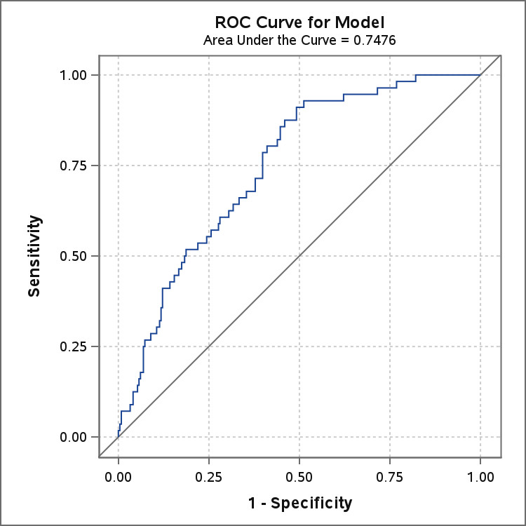
ROC Model: ROC1

Model Convergence Status
Convergence criterion (GCONV=1E-8) satisfied.

-2 Log L | = | 289.635

Analysis of Maximum Likelihood Estimates
Parameter | DF | Estimate | Standard  Error | Wald  Chi-Square | Pr >  ChiSq
Intercept | 1 | -1.4800 | 0.1481 | 99.9143 | <.0001

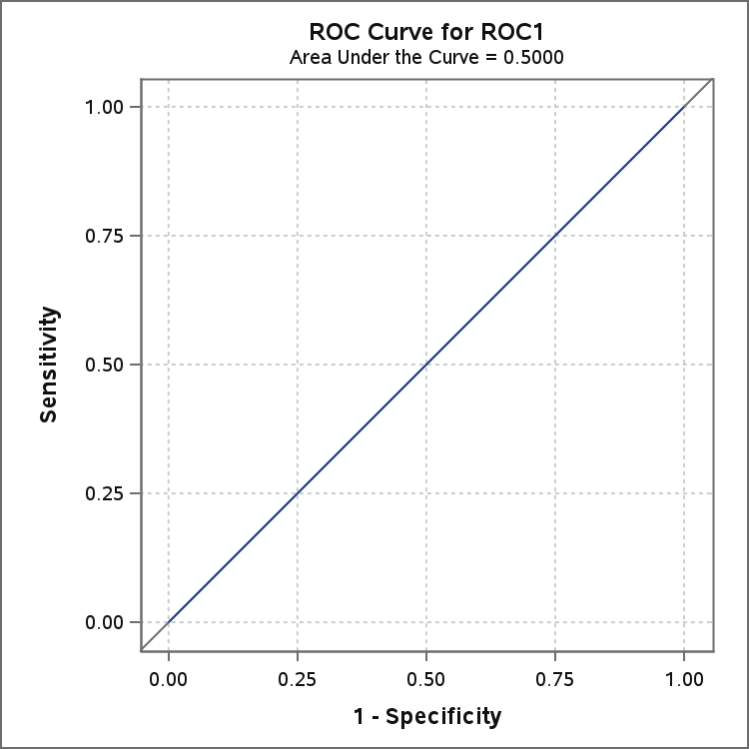
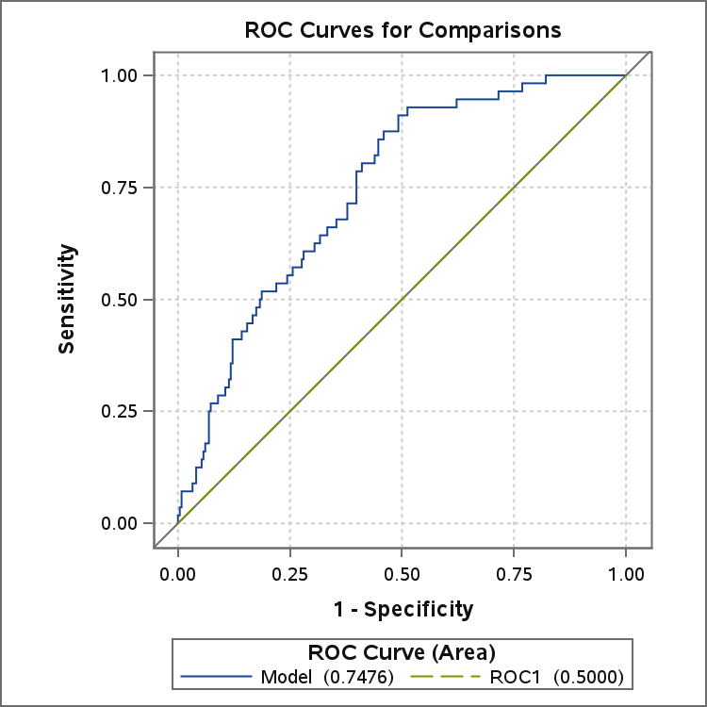

ROC Association Statistics
ROC  Model | Mann-Whitney |  |  |  | Somers'  D | Gamma | Tau-a
 | Area | Standard  Error | 95% Wald  Confidence Limits
Model | 0.7476 | 0.0326 | 0.6837 | 0.8115 | 0.4952 | 0.4952 | 0.1501
ROC1 | 0.5000 | 0 | 0.5000 | 0.5000 | 0 | . | 0

